White Paper: OceanObs 09

A global Continuous Plankton Recorder programme

Philip C. Reid, Sir Alister Hardy Foundation for Ocean Science, Marine Institute, University of Plymouth, and Marine Biological Association, Plymouth, UK
Sonia Batten, SAHFOS, Canada
Rusty Brainard, CRED PIFSC NOAA, Hawaii, USA
Peter Burkill, SAHFOS, UK
Francois Carlotti, Station Marine d’Endoume, France
Sanae Chiba, JAMSTEC, Japan
Alessandra Conversi, ISMAR, Italy
Robert Dickson, Cefas, UK
Harry Dooley, Aberdeen, Scotland, UK
Martin Edwards, SAHFOS, UK
Juha Flinkman, FEI SYKE, Finland
Joaquim Goes, Bigelow Laboratory, USA
Charles H. Greene, Cornell University, USA
John Hare NMFS, USA
Graham Hays, University of Swansea, UK
Erica Head, BIO Canada
Raleigh Hood, UMCES USA
Graham Hosie, AAD, DEWHA, Australia
Brian Hunt, UBC, Canada
Tony John, SAHFOS, UK
Tanya Jonas, SAHFOS, UK
Jack Jossie, NMFS, USA
Richard Kirby, Royal Society Fellow, University of Plymouth, UK
John Kitchener, AAD, DEWHA, Australia
Donald Kobayashi, NOAA/NMFS, Hawaii, USA
Sami Lakkis, NCMS, Lebanese University, Lebanon
Marcos Llope IEO, Spain and CEES, Norway
Alison MacDiarmid, NIWA, New Zealand
Abigail McQuatters-Gollop, SAHFOS, UK
Tom Malone, UMCES, USA
Prabhu Matondkar, National Institute of Oceanography, Goa, India
Anthony Richardson, CSIRO Marine and Atmospheric Research, University of Queensland, Australia
Karen Robinson, NIWA, New Zealand
Nils C. Stenseth, CEES, Norway
Hiroya Sugisaki, NRIFS, FRA, Japan
Darren Stevens, SAHFOS, UK
Hans Verheye, DEAT, South Africa
Luigi Vezzulli, University of Genoa, Italy

Introduction
We face major challenges in understanding how ocean biology responds to global change and possibly more importantly how life in the ocean and associated biogeochemical cycles contribute to global and especially climate change. Recent research suggests that both these challenges are considerable and of great significance for mankind. Understanding the synergistic impacts of global climate change on and from marine ecosystems requires observations on time scales of months to decades and in space at the level of ocean basins.

Plankton are a crucial component of the Earth’s biosphere since they provide the food for almost all life in the oceans and play a major role in biogeochemical cycles and climate change. Phytoplankton account for ~50% of global primary production and form the base of marine food chains. The herbivorous zooplankton graze on phytoplankton and serve to transfer energy from primary producers to fish. Most fish are planktivorous when juvenile, and many species important to humans remain planktivorous throughout their life. The carrying capacity of ecosystems in terms of the biomass of fish resources and recruitment to individual stocks is highly dependent on variations in the abundance, timing and composition of plankton populations. The plankton also play a central role in the carbon cycle through the export of organic and inorganic carbon to the deep ocean via what is known as the ‘biological pump’. Without this process, concentrations of atmospheric CO₂ would be much higher than they are now and the climate of the world (at present levels of solar radiation) would be considerably warmer. In addition to CO₂ drawdown, phytoplankton also play a key role in the production of oxygen and other climatologically relevant gases. New advances in molecular methods have allowed the study of the bacterioplankton and many new microbial organisms and processes have been discovered with a potential for commercially important bioproducts. Plankton integrate the signals of their living environment during their growth and in consequence can act as sensitive indicators of global change, often showing change well before it is detected by physical or chemical observations (Taylor et al., 2002).

Given their important roles in the biosphere, there is an urgent need to improve our ability to document changes in the abundance and distribution of planktonic organisms in both time and space. On a global scale, other than information from satellites, there is only a limited observing programme in place. In general, satellites, only provide information on chlorophyll pigments and there is poor coverage in many areas of the world due to cloud cover. However, some progress has been made recently in characterising functional groups of plankton from satellite data. The only routinely deployed sampling system that provides biological data on these scales in the oceans is the Continuous Plankton Recorder (CPR). CPRs are towed on voluntary ships of opportunity (SOOP), making the programme cost effective compared to research vessels deployed over similar large areas of ocean. Initiated in the 1930s, this robust and well tried methodology has demonstrated that it is a powerful tool for detecting, understanding and predicting the impacts of global and climate change on the biosphere as well as contributing to the understanding of feedbacks from ocean ecosystems to climate change.

Here we outline a proposal to develop and implement an integrated and appropriately funded global observation programme to sample the plankton using SOOP and where appropriate research vessels. It is envisaged that the CPR will provide a network to connect with other non-CPR traditional and new plankton sampling and analysing technologies as part of a ‘commonwealth’ of regional integrated marine observing programmes. Wherever possible the CPRs should be towed on the same ships and routes as used for the XBT, salinometer, pCO2 and other ship of opportunity measuring programmes. The vision is to achieve a coordinated global CPR programme made up of regional surveys that utilise common international standards for sampling, analysis, data processing and sample storage and that is closely associated with other SOOP and ocean monitoring initiatives.

The CPR Programme 1920 to Present

Continuous Plankton Recorders (Figure 1, 2) are towed at speeds of up to 25 knots, on standard routes, sampling the near surface plankton at a depth of ~7m (Richardson et al., 2006). The plankton is filtered by a continuously moving band of 270μm mesh silk gauze that moves through the instrument. Water enters through a small aperture at the front which expands to a rectangular cross section (10cm wide) across which passes the silk band that filters off the plankton (Figure 2). The silk slowly moves across the filtering area at a rate that is proportional to the speed of the towing ship so that five metres of silk is equivalent to ~500 nautical miles of tow. In effect the band of silk when unrolled is like a film roll of the changing plankton along the route of the towing ship. The silk is cut into samples for identification and counting of phytoplankton and zooplankton under a microscope.

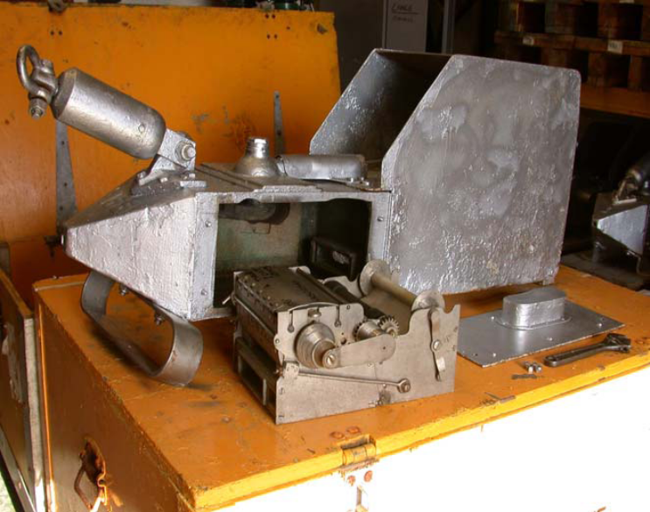

Figure 1. Photograph of a Continuous Plankton Recorder with the sampling cassette removed to show a silk spool and preservative storage tank.

Since the deployment of the prototype machine in the Southern Ocean in the 1920s (Reid et al., 2003), CPRs have been used extensively, mostly in the North Atlantic, but increasingly throughout the world. In June 1931 a smaller machine suitable for use on ships-of-opportunity was trialled between Hull and Hamburg in the North Sea. Routine monthly tows were subsequently established, later to expand into the North Atlantic (Figure 3). Since 1991 the survey has been operated by the Sir Alister Hardy Foundation for Ocean Science (SAHFOS), an internationally funded charity.

Deployment of CPR machines has proved to be an efficient and cost effective way of monitoring plankton variability, at regular monthly intervals, over large areas of oceanic and coastal water. It is the only sampling system that can provide oceanic biological data that can be used to detect interannual and decadal trends at the scale of ocean basins. A key aspect of the success of the survey resides in the standardisation and the minimal changes that have been implemented since the 1930s in the machine, methods of sampling, analysis and quality assurance procedures. Zooplankton analysis methods have changed little since prior to the Second World War and phytoplankton identification and enumeration procedures have remained virtually constant since January 1958.

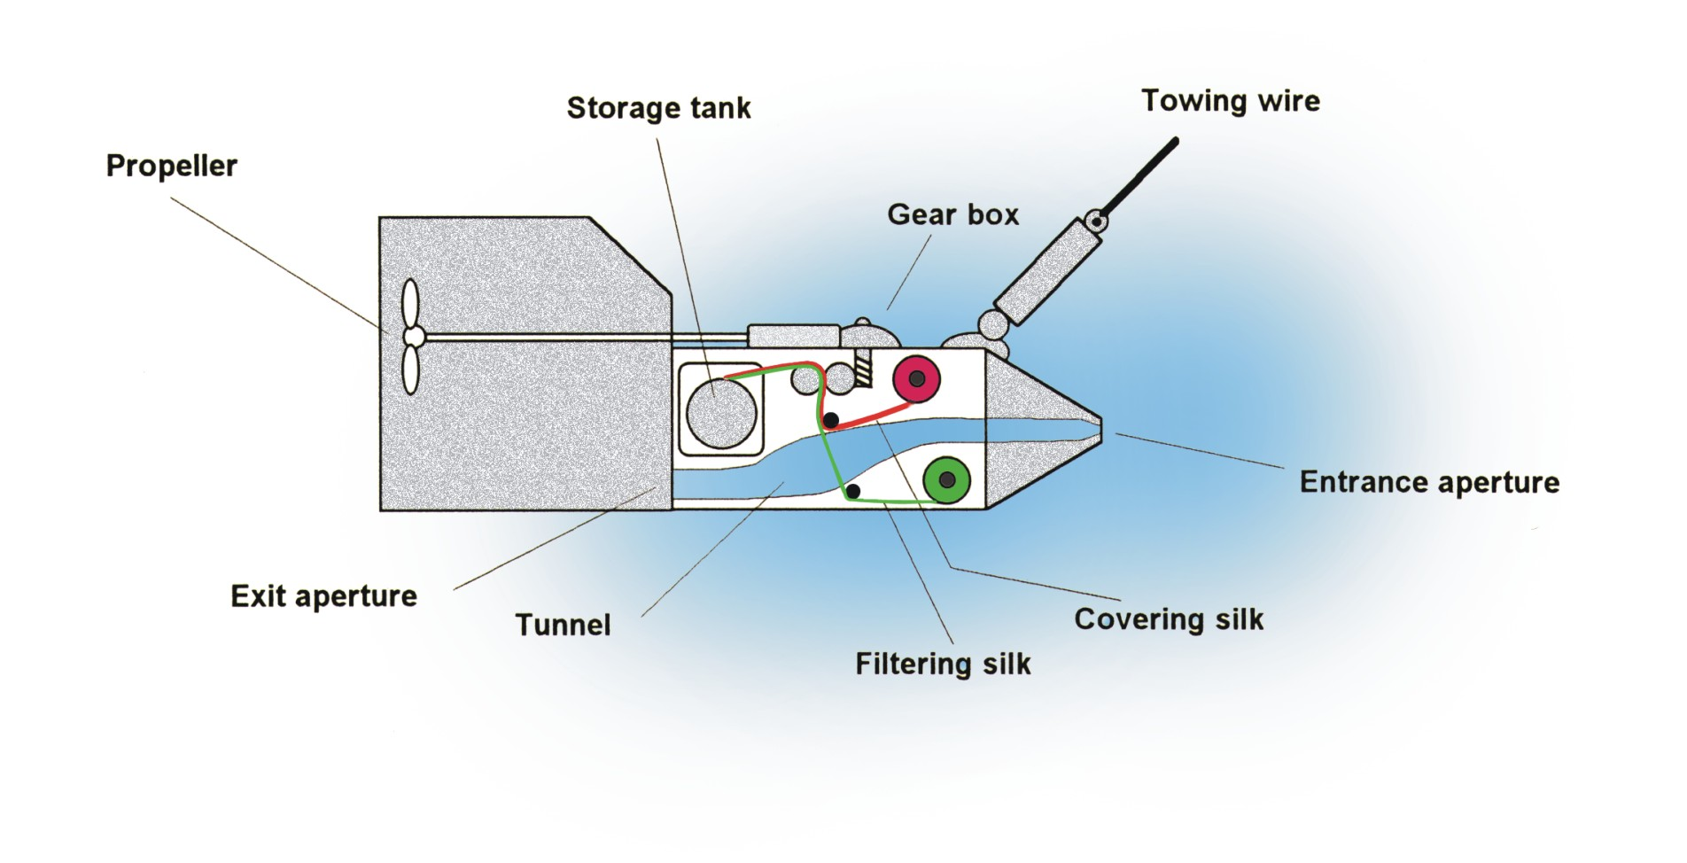

Figure 2. Schematic of the CPR showing the water passing through the filtering silk (green). The gearing mechanism is powered by an impellor. A second band of silk (red spool) covers the filtering mesh to form a sandwich that holds on the plankton as it is wound onto a spool in a storage tank containing formaldehyde fixative and preservative.

Tows have been made by CPRs in almost all the major ocean basins of the world (Figures 3, 4) and surveys are currently operational in the North Atlantic, North Pacific, Southern Ocean and in waters close to Australia and New Zealand with others in the planning stage. The Narragansett Laboratory of the NMFS in the USA has operated two CPR routes off the east coast of the USA (Jossi et al., 1999). In the North Pacific a new survey was started by SAHFOS in 1997 and now operates two routes, one between Canada and Japan (Batten, 2008). Sampling with the CPR was initiated in 2005 between South Georgia and the Falkland Islands and a new route in 2008 crosses the Barents Sea. A sister Southern Ocean survey, now adopted by SCAR, and operated by the Australian Antarctic Division (AAD), Department of Environment, Water, Heritage and the Arts, has been growing since 1991 (Hosie et al., 2003). This survey has conducted tows all around Antarctica. The resulting database from the SAHFOS, NMFS and Southern Ocean surveys of over 230,259, 8,722 and 25,791 analysed samples recording >600 species/taxa and Phytoplankton Colour (a measure of chlorophyll) has derived collectively from more than 5 million miles of tow. A new Australasian CPR survey started in 2009 along the eastern coast of Australia (Davies et al., 2008). In New Zealand a programme operated by the National Institute of Water and Atmospheric Research (NIWA), in partnership with

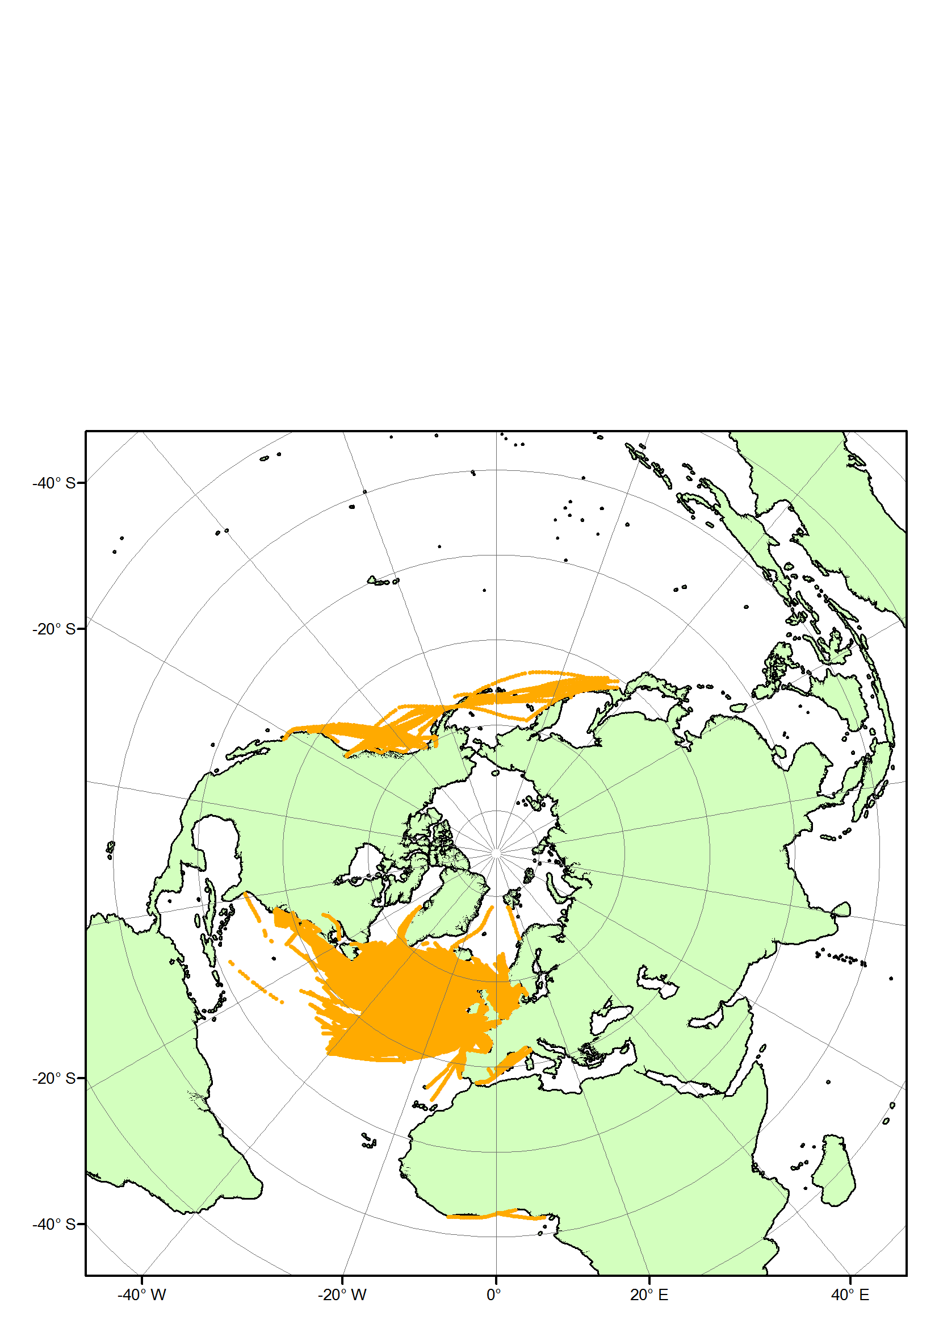

Figure 3. Map showing the positions of all analysed CPR samples in the Northern Hemisphere for the period 1931 to 2008 inclusive.

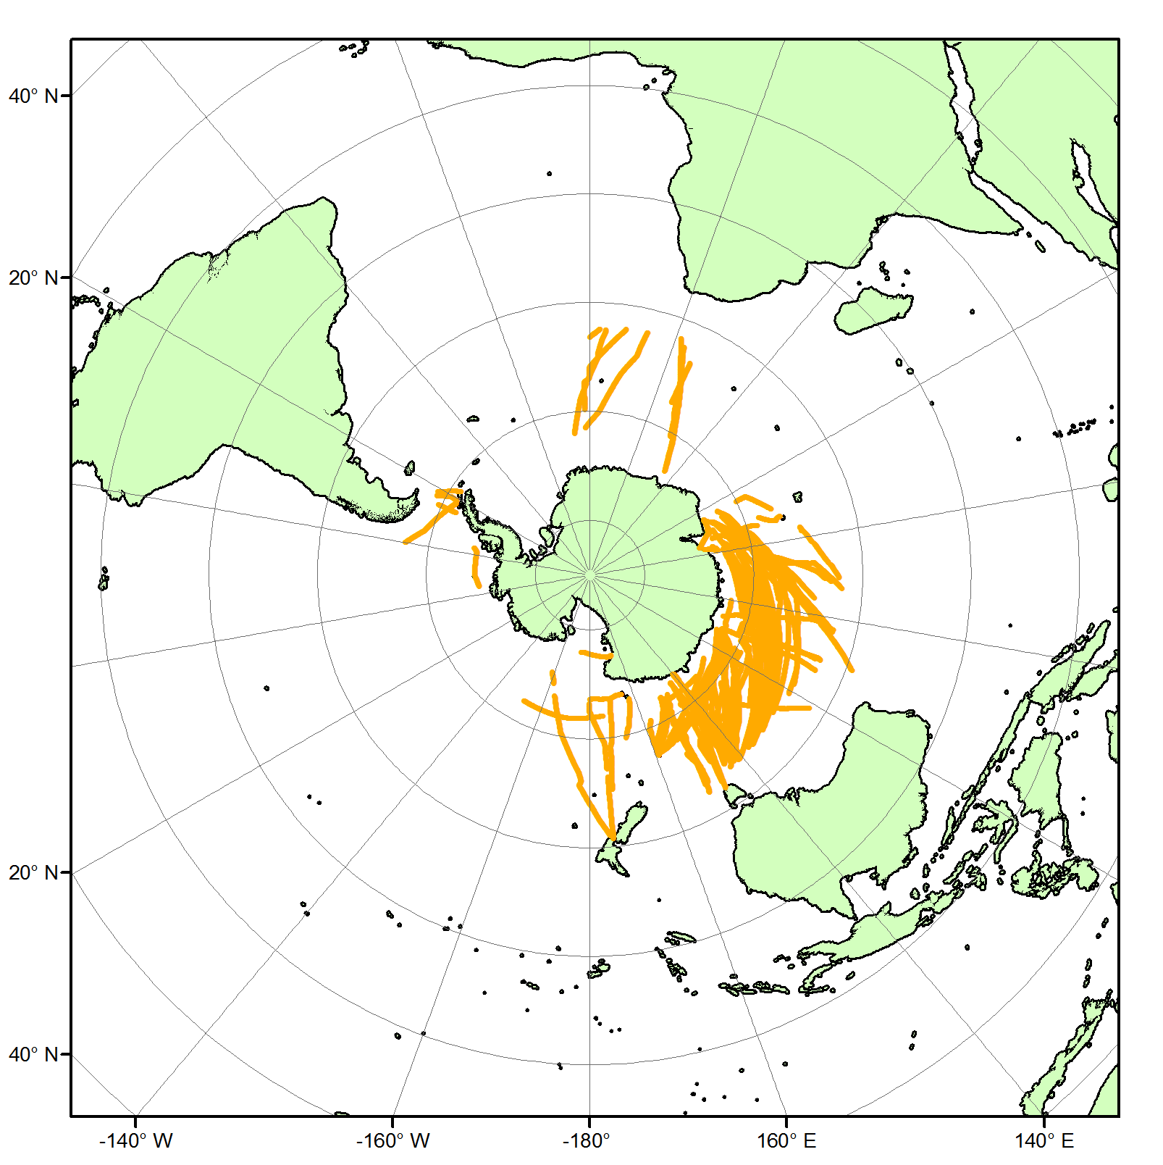
Figure 4. Map showing the positions of all analysed CPR samples in the Southern Hemisphere for the period 1991 to 2008 inclusive.
the New Zealand's Ministry of Fisheries (MFish), was started in 2008 and is towing CPRs half yearly between Wellington and Chatham Rise and on a route to Antarctica. Other pilot and historic surveys have operated in the Gulf of Guinea, the Mediterranean, Baltic and Caribbean Seas, around the Seychelles in the Indian Ocean, in the Gulf of California and in the Great Lakes. In 2005 a successful ‘proof-of-concept’ tow was made around southern Africa. A proposal has recently been submitted in South Africa to The Benguela Current Commission (BCC) to develop this survey in the long-term using ships-of-opportunity between Durban on the South African east coast and Cabinda, Angola. Plans are in hand to tow between Honolulu and the Marianna Islands, in the Gulf of California and between the UK and the Falkland (Malvinas) Islands and a proposal is being developed within the Sustained Indian Ocean Biogeochemical and Ecological Research (SIBER) initiative to operate a route across the Indian Ocean. The National Institute of Oceanography, India has purchased a CPR and is investigating options for its routine deployment in the Arabian Sea.

Some key research results
Research on data from past and current CPR surveys has proved to have a wide variety of applications with an increasing recognition of the uniqueness of the CPR time series as a ‘barometer’ against which climate change and the effects of pollution/eutrophication on the natural variability of marine populations can be assessed. Survey products have been used: to describe and analyse the biogeography, seasonal cycles and year-to-year variability of the plankton in relation to hydro-and meteorological change, to provide information on harmful algal blooms, to monitor and document the spread of non-indigenous plankton species, to describe changes in marine biodiversity and trophic cascading and to develop new modelling approaches to predict future changes in plankton distribution as a consequence of global warming. The data have also been used as environmental input to interpretation of changes in fish stocks and fisheries assessments (Brander et al., 2003). More recent applications of the data and publications are referred to in SAHFOS Ecological Status Reports (see SAHFOS.org). An Atlas of the distribution of CPR plankton was published in Marine Ecology Progress Series (Continuous Plankton Recorder Survey Team, 2004). For products from the North Pacific survey see (Batten, 2008). Equivalent information for the Southern Ocean survey can be seen at: http://data.aad.gov.au/aadc/cpr and see also (Leathwick et al., 2006) and for bioregionalisation of the Southern Ocean for CCAMLR see (Raymond and Hosie, 2009). Information on the Narragansett survey is available at: http://www.st.nmfs.noaa.gov/plankton/data/sahfosatl/index.html and the new Australian survey at: http://imos.org.au/auscpr.html .

Research based on CPR survey data has led to well over 1000 scientific publications since 1931. Output is increasing as new ways of utilising the data are being discovered. In addition, samples held in storage ad infinitum make it possible for them to be reused as new scientific approaches and techniques become available. For example the CPR has proved to be a good sampler of small plastic particles. A recent breakthrough in the extraction and characterisation of DNA from formalin preserved CPR samples has helped studies of plankton biodiversity and population biology. If the molecular analysis of CPR samples was automated data output could be maximised. Finally, the samples hold great promise for biogeochemical analysis related to ocean acidification and the biological pump.

The Need for Globalisation
A number of regional CPR programmes are now established or just starting throughout the world. It is time to build on the decadal experience of existing surveys and expand the CPR into all of the ocean basins and especially those that are climatically sensitive. To achieve this, international cooperation and the assistance of the Merchant marine and ships of opportunity will be needed. Existing and new planned CPR surveys could be integrated as part of a commonwealth of observation programmes linked to SAHFOS. The aim will be to coordinate all CPR programme and encourage common international standards of sampling, analysis, quality control, data processing and sample and data storage. An ocean-wide network of CPR surveys could act as a template to interface with other traditional and new plankton sampling and analysing technologies as part of regional integrated marine observing programmes. Putting in place a global coordinated plankton monitoring system will make it easier to achieve inter-comparisons between different ocean basins and to integrate CPR and other plankton observations within the wider remit of GOOS, GEO and other global efforts to monitor biological activity. The end goal of globalisation has to be the generation of data that is compatible and preferably freely exchangeable.

Parnership with other SOOP Monitoring Programmes
There are a number of existing and developing programmes using SOOP/VOS to monitor physico/chemical variables in the oceans, e.g. expendable bathythermographs (XBTs), salinometers, pCO₂ and acoustics (Figure 5). Because they are instrumented methodologies they already have a more extensive global network than for the CPR. In developing a global programme, wherever possible, CPRs should be deployed on the same core routes and vessels used for these other measurements and on routes that pass close to OceanSITES. There is a need to build a closer association between these different programmes so that they are not seen to be competing for ship-time by merchant ship operators. Sampling at the same time on the same route will provide benefits in terms of interpretation of change as well as possible sharing of logistics, costs and resources. There is considerable potential to deploy CPRs on untapped platforms which should be used to further understand global and basin-scale plankton dynamics and climate change.

Integration with existing and planned regional marine observing systems

The SAHFOS survey has been part of the UK National Marine Monitoring Programme for many years that also included a range of physical, chemical and contaminant measurements at a number of sites representative of estuarine, coastal and offshore waters around the British Isles. The programme has recently been restructured as the United Kingdom Marine Monitoring and Assessment Strategy (UKMMAS). The Survey that operates in the western North Atlantic forms part of the Canadian Atlantic Zone Monitoring Program (Head and Pepin, Submitted; Therriault et al., 1998), again linked to hydrographic and other measurements in Canadian waters and is used to produce annual assessments of the state of Canadian waters.

The SCAR SO-CPR Survey was established in 1991 to map the spatio-temporal patterns of zooplankton, and then to use the sensitivity of plankton to environmental change as early warning indicators of the health of the Southern Ocean (Hosie et al., 2003). The survey contributes to the Commission for the Conservation of Antarctic
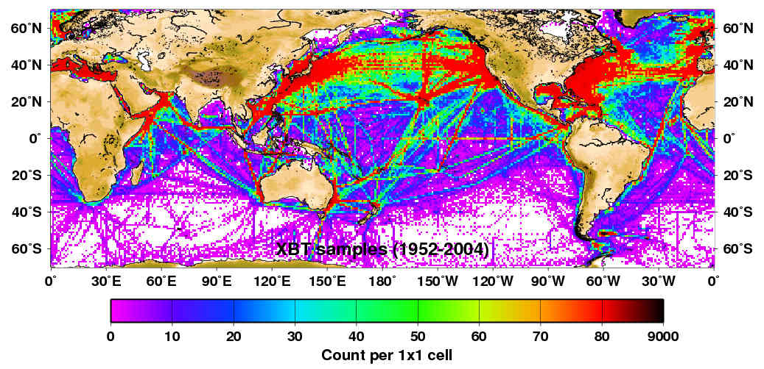
a
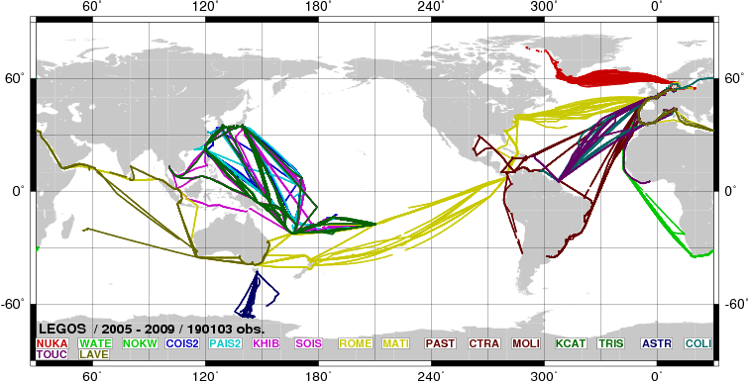
b
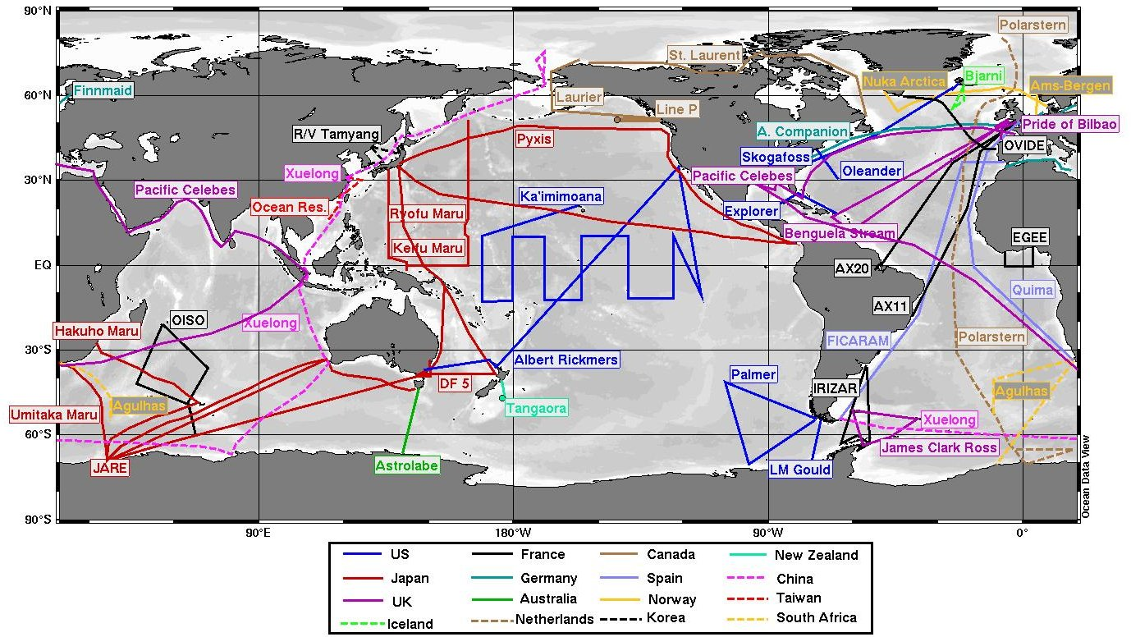
c

Figure 4. a: Dominant shipping routes and intensity of sampling by SOOP/VOS for XBTs (1952-2004), (plot courtesy of Wm.A.Stafford, Rutgers University).
b: Location of ship routes that have deployed thermosalinographs in real-time monitoring on SOOPs in the period January 2005 to September 2009 inclusive. Source: LEGOS/SSSOS http://www.legos.obs-mip.fr/en/share/soa/cgi/getobs/v0.2/index.pl.cgi?contexte=SSS&donnees=TSG&suivi=TPS-REEL&env=NAVIRE&menu=SPATIAL
c: Ongoing (and planned) routes used for surface measurement of pCO2 on SOOP. Source: IOCCP http://ioc3.unesco.org/ioccp/Underway/New_GlobalUWMap.html
Marine Living Resources (CCAMLR) Ecosystem Monitoring Program (C-EMP), is a foundation component of the SCAR/SCOR Southern Ocean Observing System (SOOS) and contributes to the developing Southern Ocean Sentinel programme. Fourteen countries have participated in the Survey to date to provide a near circum-Antarctic Survey. Southern Ocean CPRs are towed from research and supply vessels (mostly in the austral summer) that simultaneously collect underway environmental data. In Australia CPR routes will interface with monthly plankton results from nine single point ‘national reference stations’, and will incorporate CPR data from SO-CPR operations south of Australia.

The best aspects of all these monitoring initiatives should be used as a model for the development of future regional programmes to establish a global ‘Commonwealth’ of biological surveys. At a minimum these efforts should include remote sensing of Ocean Colour and the Global Tracking Network for fish, marine mammals, turtles and other organisms. Integrating these different systems will provide a powerful mechanism to achieve synoptic comparisons between data on phytoplankton (remote sensing and CPR), zooplankton, fish larvae (CPR), and fish (Global Tracking Network and stock assessment surveys). For successful development within a GOOS context it is imperative that future programmes develop in partnership with parallel measurements of the physics and chemistry.

European Union: Marine Strategy Framework Directive (MSFD)
A new opportunity to establish a CPR programme in all European regional seas is possible under the new MSFD. Good environmental status targets for biological diversity, non-indigenous species, status of fish stocks and of the marine food web, eutrophication, benthic ecosystems and marine litter as well as indicators for each regional sea have to be developed by 2012 and an established monitoring programme by 2014 that includes both phyto and zooplankton. Monitoring systems have to be compatible between each regional sea and with existing programmes. CPRs have already been successfully towed in the Northeast Atlantic, North, Norwegian, Barents, Baltic and Mediterranean seas, over decades in many areas. The natural variability of biological indicators has to be considered and this can only be achieved through long time series. Furthermore the standardisation of CPR methodologies allows comparability between different regional seas. Finally, CPR indicators are already in use by governments, the European Environment Agency and OSPAR. The CPR could provide a cost-effective means of monitoring for the MSFD as it can simultaneously contribute many of the required indicators. CPR results provided some of the most convincing evidence for observed changes in marine ecosystems for IPCC AR4.

Linkages to GOOS, GEO, SCAR, SCOR/IAPSO OceanScope, SIBER, OceanSITES
The proposals outlined in this White Paper will be developed in close cooperation with other observational themes developed by the new SCOR/IAPSO working group ‘OceanScope’, ocean basin research proposals such as SIBER and initiatives within GOOS as well as linking to plankton assessments from remote sensed observations. The aim is to make best use of existing platforms to develop a coordinated whole.

Data storage and data processing
SAHFOS has invested sizeable resources into a new data input, storage and data extraction system that could be a model for a global database system. The SO-CPR uses a different system that includes data from measurements taken on the towing research vessel. To facilitate intercomparisons at ocean basin and regional scales between different CPR and other programmes there is a need to standardise data storage and processing procedures wherever possible and agree procedures for a global, preferably distributed database system. Procedures for access to raw data for use by modellers need to be put in place. A debate is needed on migrating to an international standard for taxonomic identifiers within each survey. Currently SAHFOS data are available from David Johns, Data Manager, djoh@sahfos.ac.uk. Data for the Southern Ocean survey are held at the Australian Antarctic Data Centre http://data.aad.gov.au/aadc/cpr/ and at the SCAR Marine Biodiversity Information Network (SCAR-MarBIN) portal www.scarmarbin.be . The new programme in Australia forms part of the Integrated Marine Observing System (IMOS) with all data from hydrographic, chemical and other measurements incorporated into a central database.

Protocols and Methods
Since 1931 a CPR Manual has been regularly updated for all logistic, sampling, analysis and data processing protocols and a version of this manual has been produced more recently for the SO-CPR survey. A global version of this manual is needed that identifies differences between regional procedures, gives appropriate guidance on quality control and outlines standard training procedures. Taxonomic identification guides (with a section on molecular analysis) need to be maintained for different parts of the world. Small differences already exist between regional surveys that have crept in or were deliberately introduced due to local conditions e.g. species and stages analysed, numbers of nautical miles in a sample, on/off silk analysis.

A special role for SAHFOS
Within this global plan we suggest that SAHFOS, because of its past experience in establishing new and pilot plankton surveys and its taxonomic and logistical skill base, should play a central role as: a centre of advice, and expertise in survey design, quality control, databasing and coordination. It could also act as a global ‘Centre of Excellence for Plankton Taxonomy and Ecology’ and as a training centre to help establish new satellite laboratories and train their staff in analysis, QC and curation. To achieve these ends there is a need for:
- New infrastructural and budgetry support for these roles in SAHFOS.
- Staff at SAHFOS who are focussed on provision of advice, facilitating the development of new surveys plus work on plankton taxonomy and ecology.
- Support to enable SAHFOS to produce cost estimates for new surveys.
- A revision of the SAHFOS guide to the development of new surveys and publication of the guide on the www.
- A coordinating role for databasing and QC of data (see below).
- Coordination of analysis and research on global results.
- Production and maintenance of a global CPR manual for all protocols.
- Improved facilities for molecular and biogeochemical analysis in cooperation with partner institutions.
- Facilitating exchange of expertise and staff between different regional CPR programmes.
- Training workshops on plankton taxonomy.

Financing CPR surveys
It is worth drawing attention to the history of how the North Atlantic survey has been funded as it provides insight into past mistakes and helps identify considerations that need to be addressed to achieve a global integrated CPR programme in the future. From its beginning in 1931 to 1989 what is now the SAHFOS North Atlantic survey was funded from research budgets by a succession of UK government agencies. In 1989 cuts had to be made and the survey was closed. Following an international outcry the survey was reopened the following week until a new charitable foundation (SAHFOS) was established to run the survey from April 1991. Since then more than 10 countries have supported the survey and it has expanded like a phoenix to cover a much larger area of the world’s oceans. In 2007 core funding for SAHFOS derived from two UK agencies, NERC and Defra, comprising ~two thirds of the total funds and the remaining one third was funded by contracts requiring specific deliverables from more than a dozen research organisations in six countries, including the UK, and the European Union. The SAHFOS Pacific survey, which started with four pilot tows in 1997, is developing along similar lines with agencies from the USA, Canada contributing to the funding package and with a contribution in 2009 from the JSPS (Japan Society for the Promotion of Science, MEXT) to support sample analysis in Japan.

Funding by NOAA, USA supported an extension into the Northwest Atlantic between 1960 and 1979. After 1979 support from NOAA ceased and sampling stopped until 1991 when, under SAHFOS, routes were again opened with support from Canada and NSF, USA. The long gap in sampling between 1980 to 1991 in the Northwest Atlantic coincided unfortunately, with the collapse in the cod fishery and a major environmental change in the area. If the survey had been operational during this period it would have provided invaluable input to understanding the causes of the changes in cod stocks.

The temporary closure in the late 1980s had a major impact on the survey. All operations retreated to 20° west in the east Atlantic, with a reduced sampling coverage and the analysis of samples ceased. In this period of uncertainty all the pre-war archived samples and samples prior to 1958 were thrown away. It now seems unbelievable that the true value of these well curated and preserved samples was not recognised. It is fortunate that the survey survived as a major regime shift occurred in this area ~1988 that would not have been recognised if the closure had been complete. When the survey restarted after 1991 under a new funding regime it came close to bankruptcy on three occasions because of cash flow problems as a result of short (one year) multi-contract funding.

Surveys outside SAHFOS are serviced directly by Government agencies. The NMFS SOOP CPR survey operates two short routes in the West Atlantic and is funded directly by NOAA, but most sample analysis is contracted out to Poland. The Southern Ocean Survey is supported by the individual government and research institutes of the survey partners. A small amount of funding is provided by SCAR to support the Expert Group on CPR Research which helps promote the survey. The SO-CPR survey uses the supply vessels of AAD and is funded directly as part of the programme of AAD in the Southern Ocean and Antarctica, with contributions from other National Antarctic surveys that fund tows on their supply vessels. AusCPR is funded within the new Australian IMOS initiative until 2011. In New Zealand, NIWA has secured funding from Mfish for five years from 2008.

The main problems of current funding approaches are short-termism, lack of security and efficiency in supporting multiple contracts, minimal funding for research on the data and for archiving. The goal is to achieve a global perspective via a series of regional surveys. Long term secure funding is needed to ensure consistency between surveys. To progress to a global programme, regional sea systems need to be put in place, initially with multiple funding to the SAHFOS model, moving to regional support e.g. potentially from the European Union to address the Marine Strategy Framework Directive. If possible at a global scale and in the longer term funding needs to follow the model used for global meteorological observations where funds are obtained directly from governments as contributions to the work of WMO. A business plan needs to be developed that looks at different costing scenarios for global development. A full European/North Atlantic programme is estimated to cost ~5 million Euros/dollars. An additional ten million Euros/dollars would provide a very basic survey throughout the rest of the world.

Operational products and Outreach
Other than for measures of sea surface temperature for meteorological services the SAHFOS CPR survey was probably the first truly operational oceanographic programme to be started in the world as it has provided products to governments, industry and the public from the very beginning in 1931. In developing a vision of how the spatially extensive areas of the global ocean should be sampled for plankton and its variability in the future and how such a programme should be integrated with other initiatives under a Global Ocean Observing Programme, it is essential that the results should continue to serve the needs and provide benefits to a wide user community. A focus should also be placed on the development of indicators, as not everything can be measured. CPR data, because of the large number of organisms identified and counted are particularly well suited to this type of application. Appropriate outreach and operational products need to be produced that are of value to governments, policy makers, researchers, modellers, remote sensors and the public at coastal, regional, oceanic and global scales.

Concluding comments
A global plankton dataset is urgently needed to help understand the role of plankton in climate and for input to models. The data should be complemented by additional biological environmental and climatic indicators. Achieving consistency in sampling and analysis is essential whilst still accommodating local survey needs. Additional measurements should be obtained from instrumented CPRs and on the tow ships to complement the plankton results. It is now possible for example to attach a water sampling system to a CPR that allows the microbial and smaller components of the plankton to be quantitatively measured. It is possible to attach a range of other instruments to complement the plankton data. The success of regional programmes will require a close working relationship with the shipping industry.

References
Batten, S.D., 2008. The North Pacific Continuous Plankton Recorder Survey. PICES Press, 16(2): 19-21.
Brander, K.M., Dickson, R.R. and Edwards, M., 2003. Use of Continuous Plankton Recorder information in support of marine management: applications in fisheries, environmental protection, and in the study of ecosystem response to environmental change. Progress in Oceanography, 58(2-4): 175-191.
Continuous Plankton Recorder Survey Team, 2004. Continuous Plankton Records: Plankton Atlas of the North Atlantic Ocean (1958-1999). II. Biogeographical charts. Marine Ecology Progress Series Supplement 11-75.
Davies, C. et al., 2008. The Australian Continuous Plankton Recorder (AusCPR) survey:
a plankton observing system in Australian waters. GLOBEC Newsletter, 14(2): 17-18.
Head, E. and Pepin, P., Submitted. Long-term variability in phytoplankton and zooplankton abundance in the NW Atlantic in Continuous Plankton Recorder (CPR) samples, Department of Fisheries and Oceans, Dartmouth, Canada.
Hosie, G.W., Fukuchi, M. and Kawaguchi, S., 2003. Development of the Southern Ocean Continuous Plankton Recorder Survey. Progress in Oceanography, 58(2-4): 263-283.
Jossi, J.W., Goulet, J.R., Green, J.R. and Kane, J., 1999. Gulf of Maine and Georges Bank zooplankton retrospective from CPR and MARMAP surveys.
Leathwick, J.R., Elith, J., Francis, M.P., Hastie, T. and Taylor, P., 2006. Variation in demersal fish species richness in the oceans surrounding New Zealand: an analysis using boosted regression trees. Marine Ecology Progress Series, 321: 267-281.
Raymond, B. and Hosie, G., 2009. Network-based exploration and visualisation of ecological data. Ecological Modelling, 220(5): 673-683.
Reid, P.C., Colebrook, J.M., Matthews, J.B.L. and Aiken, J., 2003. The Continuous Plankton Recorder: concepts and history, from Plankton Indicator to undulating recorders. Progress In Oceanography, 58(2-4): 117-173.
Richardson, A.J. et al., 2006. Using Continuous Plankton Recorder Data. Progress in Oceanography, 68: 27-74.
Taylor, A.H., Allen, J.I. and Clark, P.A., 2002. Extraction of a weak climatic signal by an ecosystem. Nature, 416(6881): 629-632.
Therriault, J.C. et al., 1998. Proposal for a northwest zonal monitoring program. Canadian Technical Report of Hydrography and Ocean Sciences, 194: 64pp.

5174 words

